Petrochemical Products

Introduction:
Petrochemicals (sometimes abbreviated as petchems) are the chemical products obtained from petroleum by refining. Some chemical compounds made from petroleum are also obtained from other fossil fuels, such as coal or natural gas, or renewable sources such as maize, palm fruit or sugar cane.
The two most common petrochemical classes are olefins (including ethylene and propylene) and aromatics (including benzene, toluene and xylene isomers).
Oil refineries produce olefins and aromatics by fluid catalytic cracking of petroleum fractions. Chemical plants produce olefins by steam cracking of natural gas liquids like ethane and propane. Aromatics are produced by catalytic reforming of naphtha. Olefins and aromatics are the building-blocks for a wide range of materials such as solvents, detergents, and adhesives. Olefins are the basis for polymers and oligomers used in plastics, resins, fibers, elastomers, lubricants, and gels.
Global ethylene production was 190 million tonnes and propylene was 120 million tonnes in 2019.^{[4]} Aromatics production is approximately 70 million tonnes. The largest petrochemical industries are located in the USA and Western Europe; however, major growth in new production capacity is in the Middle East and Asia. There is substantial inter-regional petrochemical trade.
Primary petrochemicals are divided into three groups depending on their chemical structure:
- Olefins includes ethene, propene, butenes and butadiene. Ethylene and propylene are important sources of industrial chemicals and plastics products. Butadiene is used in making synthetic rubber.
- Aromatics includes benzene, toluene and xylenes, as a whole referred to as BTX and primarily obtained from petroleum refineries by extraction from the reformate produced in catalytic reformers using naphtha obtained from petroleum refineries. Alternatively, BTX can be produced by aromatization of alkanes.^{[5][6][7]} Benzene is a raw material for dyes and synthetic detergents, and benzene and toluene for isocyanates MDI and TDI used in making polyurethanes. Manufacturers use xylenes to produce plastics and synthetic fibers.
- Synthesis gas is a mixture of carbon monoxide and hydrogen used to make ammonia and methanol. Ammonia is used to make the fertilizer urea and methanol is used as a solvent and chemical intermediate. Steam crackers are not to be confused with steam reforming plants used to produce hydrogen and ammonia.
- Methane, ethane, propane and butanes obtained primarily from natural gas processing plants.
- Methanol and formaldehyde.

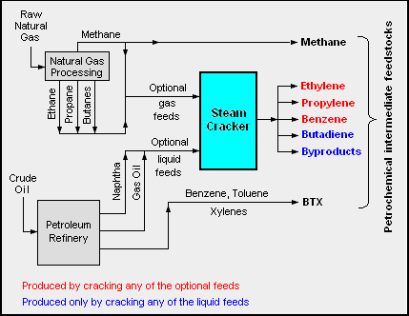

Classification Of Petrochemicals:
After being extracted from the Earth's crust, petroleum is transported to oil refineries for separation and purification. The different compounds in petroleum are mostly nonreactive, but have a range of boiling points, meaning they can be separated using heat via a process called "fractional distillation." The lightest, most volatile compounds boil at around 70 degrees Fahrenheit with the heaviest, least volatile boiling at more than 750 degrees Fahrenheit.

Light Petrochemicals:
The light petrochemicals are used as bottled fuel and raw materials for other organic chemicals. The lightest of these -- methane, ethane and ethylene -- are gaseous at room temperature. Natural gas, the gas supplied to buildings, is primarily methane with an added odorant so it can be detected easily. The next lightest fractions are comprised of petroleum ether and light naphtha with boiling points between 80 and 190 degrees Fahrenheit.

Medium Petrochemicals:
Hydrocarbons with between 6 and 12 carbons are called "gasolines" and are mostly used as automobile fuels. Octane, with eight carbons, is a particularly good automobile fuel, so a gasoline mix with a proportion of octane is considered to be of high quality. Kerosenes contain 12 to 15 carbons and are used as aviation fuels, as solvents and for heating and lighting.

Heavy Petrochemicals:
Heavy petrochemicals are used as diesel oil, heating oils for buildings and lubricating oils for engines and machinery. These contain between 15 and 18 carbons with boiling points between 570 and 750 degrees Fahrenheit. The heaviest fractions of all are called "bitumens" and are used to surface roads or for waterproofing. Bitumens can also be broken down into lighter hydrocarbons using a process called "cracking."

Sources of Petrochemicals:
Oil is a very highly sought-after resource, but most of the world's oil comes from a few countries. The majority of these are in the Middle East, including Saudi Arabia, the United Arab Emirates, Iran and Iraq. Other major producers include the United States,

Russia, Mexico and Venezuela. It took tens of millions of years to produce this oil; however, according to the "The Independent" it is predicted that, at current rates of consumption, supplies could be exhausted by 2030.

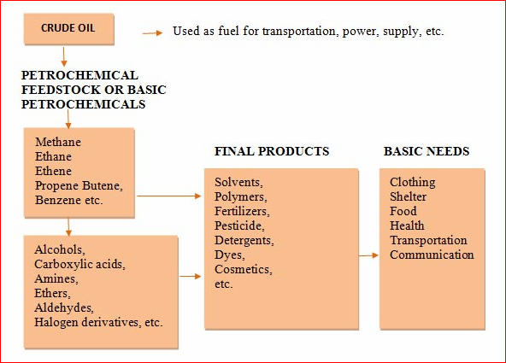

Pantomimical product and Uses:
Petrochemicals are a set of chemical compounds that fuel a wide array of products across the globe. They are made of hydrocarbons that are separated and extracted from petroleum (crude oil) and natural gas are at the core of multiple industries.
including:
- Cosmetics
- Electronics
- Packaging
- Textiles
- Toiletries

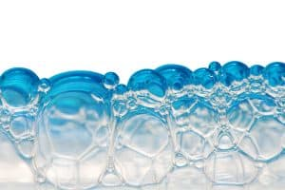
A vast majority of petrochemicals are obtained from fossil fuels, such as natural gas and crude oil. The rest usually comes from coal and biomass. A major, if not the most important element of the industry is the petrochemical plant itself.
These plants are the powerhouses that convert the natural resources into petrochemicals to be used as the building blocks for other processes and products.
Increasingly complex, these plants are both impressive in size and engineering, meeting the growing needs, expectations, and demand of today’s global economy.
The process requires energy in huge amounts and involves a distillation phase, in which hydrocarbons are separated from the fossil fuels. The separated hydrocarbons are then sent to facilities called “crackers”. These facilities convert them into useful chemicals, known as “feedstock”.
Chemical feedstock refers to any type of unprocessed material used in a manufacturing process as a base material to be transformed into another end product.
The primary class of petrochemical feedstock includes:
- Olefins (ethylene, propylene, and butadiene)
- Aromatics (benzene, toluene, and xylenes)
- Methanol

Basic petrochemicals such as these are the basis of many products, including plastic, paper, fibers, adhesives, and detergents. They are also responsible for producing a whole gamut of chemicals known as petrochemical intermediates.
These derivatives are more complex versions of primary petrochemicals. They are also used in making a variety of products. Some typical examples include:
- Vinyl Acetate – used in making paint
- Ethylene Glycol – used in polyester textile fibers

Petrochemicals form the backbone of modern economies and are found in a wide range of consumer and industrial products, many of which are considered essential for daily use.
Highly versatile, petrochemicals can be found in everything from synthetic tires to automotive headlamps and lenses. While most individuals associate these chemicals with plastics, their potential uses span a much broader spectrum of applications, from household groceries to rocket propulsion.

Key Products Made From Petrochemicals

Petrochemicals form the backbone of modern economies and are found in a wide range of consumer and industrial products, many of which are considered essential for daily use.
Highly versatile, petrochemicals can be found in everything from synthetic tires to automotive headlamps and lenses. While most individuals associate these chemicals with plastics, their potential uses span a much broader spectrum of applications, from household groceries to rocket propulsion.
The use of petrochemicals in everyday household products is too widespread to list them all here. The following list is a summary of some of the most common uses of petrochemicals:
- Hydrocarbons in manufacturing and transportation
- Resins, films, and plastics in medicine
- Preservatives in food or use in food packaging
- Agriculture, from plastics and pesticides to fertilizers
- Household products, such as carpeting, detergents, and more
- Rubber
- Synthetic fibers
- Adhesives
- Dyes
- Paints and coatings

Petrochemicals Are Used in Manufacturing

Examples of how petrochemicals are used for manufacturing include:
- Solar panels
- Thermal insulation for buildings
- Parts of electric vehicles
- Batteries
- Wind-turbine blades

Above, we detailed some of the common product categories in which petrochemicals are used.
As you can see, they span a range of both commercial and consumer products that many of us use in our everyday lives.
Let’s look closer at the order of production – from the early refinement to the end-user.

The Order of Petrochemical Processing – From Raw Material to Final Usage:
There are five steps in the order of petrochemical processing that turn raw materials into a variety of products.
- Feedstocks
- Basic Chemicals
- Chemicals Intermediates / Derivatives
- Manufacturing Products
- Consumer Products

1. Feedstocks | 2. Basic Chemicals | 3. Chemical Derivatives | 4.Manufacturing Products | 5. Consumer Products
natural gas | ethylene | styrene | I  ndustrial chemicals | clothing
ethane | propylene | ethylene glycol | plastics | packaging
Propane | butylene | Isobutylene | R  esin paints & coatings | appliances & electronics
butane | butadiene | Acrylonitrile | synthetic rubbers | vehicles & machinery
condensate | aromatics | glycerine | explosives | office & industrial equipment
naphtha | ammonia |  | foams | pharmaceuticals & personal care
 | methanol |  | dyes | building materials

Petrochemicals – A Sunrise Industry

Petrochemicals are present in nearly everything we use. A report by the International Energy Agency says that petrochemicals are the largest driver of global oil demand. The industry is fairly new and is touted to grow significantly in the future, which is what makes it known as a “sunrise industry”.
In a world that heavily depends on petrochemicals for sustenance, it’s clear they’re critical to modern societies and economies. Since petrochemical plants are the backbone of petrochemical production and management, it is clear that innovation in plant development and engineering is key to the future success of the industry.

Petroleum product

Oil refineries will blend various feedstocks, mix appropriate additives, provide short-term storage, and prepare for bulk loading to trucks, barges, product ships, and railcars.^{[3]}
- Gasses like propane and methane are stored within petroleum.
- Liquid fuels blending (producing automotive and aviation grades of gasoline, kerosene, various aviation turbine fuels, and diesel fuels, adding dyes, detergents, antiknock additives, oxygenates, and anti-fungal compounds as required). Shipped by barge, rail, and tanker ship. May be shipped regionally in dedicated pipelines to point consumers, particularly aviation jet fuel to major airports, or piped to distributors in multi-product pipelines using product separators called pipeline inspection gauges ("pigs").

- Lubricants (produces light machine oils, motor oils, and greases, adding viscosity stabilizers as required), usually shipped in bulk to an offsite packaging plant.

- Paraffin wax, used in illumination (candle wax) and other uses. May be shipped in bulk to a site to prepare as packaged blocks.
- Slack wax, a raw refinery output comprising a mixture of oil and wax used as a precursor for scale wax and paraffin wax and as-is in non-food products such as wax emulsions, construction board, matches, candles, rust protection, and vapour barriers.
- Sulfur, by-product of sulfur removal from petroleum, which contain percent of organosulfur compounds.
- Bulk tar shipping for offsite unit packaging for use in tar-and-gravel roofing or similar uses.
- Asphalt, used as a binder for gravel to form asphalt concrete, which is used for paving roads, lots, etc. An asphalt unit prepares bulk asphalt for shipment.
- Petroleum coke, used in specialty carbon products such as certain types of electrodes, or as solid fuel.

Over 6,000 items are made from petroleum waste by-products, including: fertilizer, flooring (floor covering), perfume, insecticide, petroleum jelly, soap, vitamins and some essential amino acids.^{[13]}
Oil can be used to make many products in a way that is more sustainable than use as a fuel, which creates pollution.


Sample of Crude oil (petroleum)

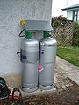
Cylinders of Liquified petroleum gas

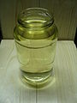
Sample of Gasoline

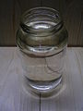
Sample of Kerosene

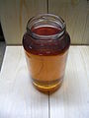
Sample of Diesel fuel


Motor oil

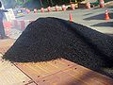
Pile of asphalt-covered aggregate for formation into asphalt concrete

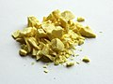
Sulfur

The following graphs present commodity future prices over the periods of the last week, last three months and last year. All changes are measured in US Dollars and reflect daily closing prices for the forward month futures.



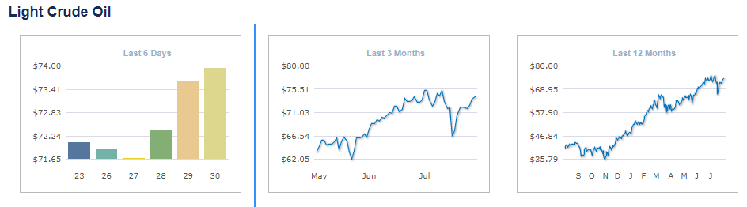

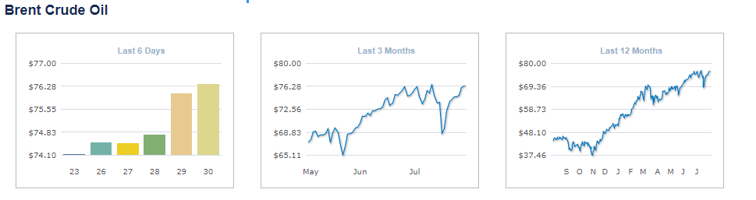

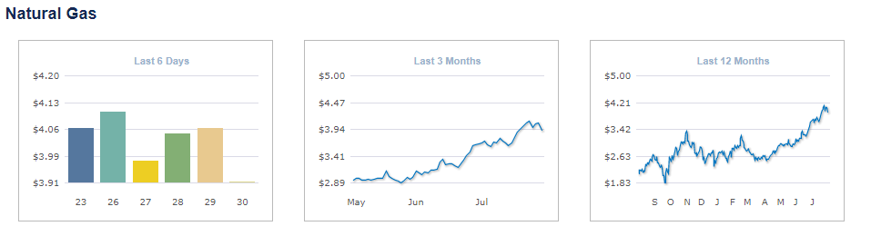

These prices are valid and updated according to the international markets and prices.

Singerly
Eng. MazinYahia

