6- Some products do not open on the tablet. This is a link, for example, a list we have when you open it on the tablet does not workhttps://sinaha.ae/index.php?route=product/category&path=349 -> Working fine

(( In the English language, when you open any section on the tablet, the products do not open, but in the Arabic language they work ))

**Respons:- When we checked that time we did no face issues as you mentioned. Now as per your concern we will check it again and if error then we will resolve.**

3- Add to  this form the  bank information fields  (Bank name - account holder name - account number – IBAN) And we are saved -> Done (<https://prnt.sc/uc07qi> <https://prnt.sc/uc0840>)

There are two things: First, if data is saved in the payment option (Other Payment Info (Bank)) its data is not saved and we attach a picture to that. Also, the options are translated into Arabic, which are:

Bank Name >> “اسم البنك”

Account Holder Name >> “اسم صاحب الحساب”

Account Number >> “رقم الحساب”

IBAN >> “ رقم ال IBAN”

**Respons:- Done**

10- When ordering from the sinaha store , we need in every request to receive a full invoice with all the details on the following email sinaha.ae@gmail.com , info@sinaha.ae , care@sinaha.ae -> Done (<https://prnt.sc/uc2w1f>)

For those who receive a similar email, but what we got is this picture. 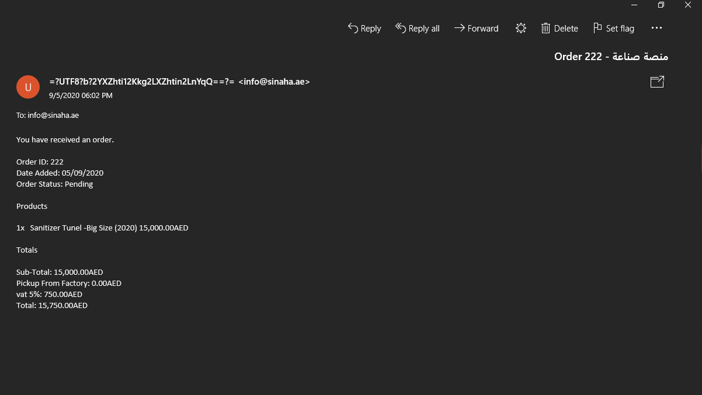

**Respons:- This one is the default order Mail which is send from Opencart end when order placed and in this order we have added our local mail so customized mail send to our mail. Kindly check this feature by creating new order it will work fine.**

7- In the event that you have registered with us as a factory. The request has been made from the factory. The factory does not reach any email informing him that a request has been requested from you. We want when any request is requested from any factory, an email is sent to him informing him that such a request has been made and the invoice is sent to him in full containing the sinaha logo  
  
There is the feature in the Marketplace module where you can design the seller mail templates according to you and assigned it Marketplace module configuration.(<https://prnt.sc/uc1fwf>)  
To know how to create a Mail template or complete the workflow of the module then you can read our user-guide <https://webkul.com/blog/opencart-marketplace-multi-vendor-module/> everything is mentioned on it.

We want to reach the factory with the same invoice that is sent here in the link<https://prnt.sc/uc2w1f> . When every request, the invoice is sent to the merchant and the customer, as the invoice contains the tax, contact numbers and everything

**Respons:- Means you want that the same** [**https://prnt.sc/uc2w1f**](https://prnt.sc/uc2w1f) **mail send to the customer(along with opencart default order mail), seller as well or only customized mail sends. Kindly confirm.**

**Note:- Please purchase the more hours so that we can start the further work on your site.**